Hotel Internet Services Announces FlixFling Partnership With Hotel Internet Services, Will Power BeyondTV Movie Service In Hotel Locations Nationwide

The Philadelphia-based streaming company
launched the service at CES 2018 in Las Vegas.

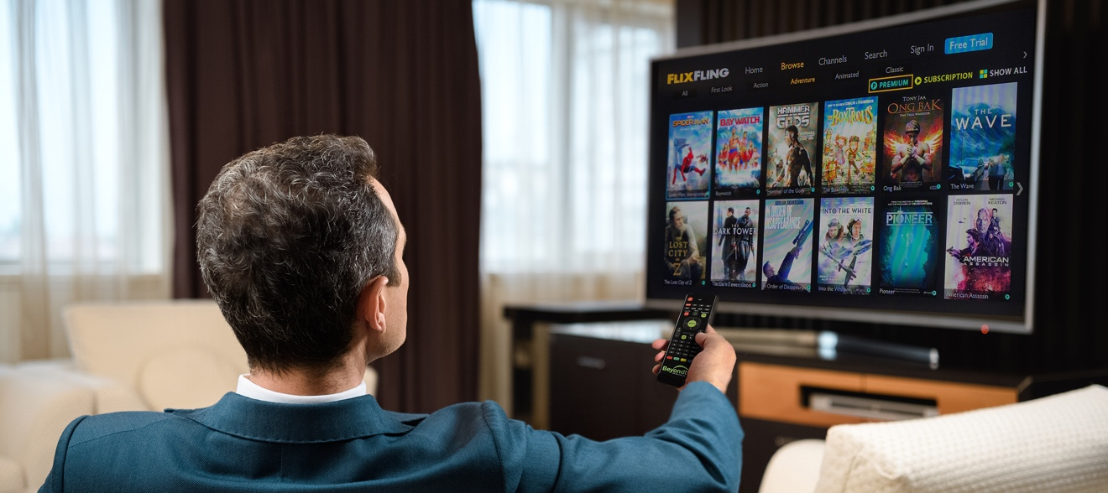

Las Vegas, NV – January 11, 2018 – Hotel Internet Services (HIS), a leading full-service provider of Internet services and TV solutions for the hospitality industry, has announced that Philadelphia-based OTT streaming company FlixFling will power its proprietary BeyondTV movie service in numerous locations nationwide. The service will be available to hundreds of thousands of guests in numerous hotels at the click of a TV remote.

FlixFling launched the service at the 2018 International Consumer Electronics Show (CES) in Las Vegas on January 9, 2018 in over 3,500 BeyondTV hotel rooms at multiple properties across the U.S. Boasting a robust catalog of major studio as well as independent films, songs, and music videos, FlixFling will offer demonstrations throughout the event’s entirety at its Suite at the Westgate Hotel.

“FlixFling is thrilled that Hotel Internet Services recognized the quality of our offering and chose our service to power their movie offering for their hotel clients” said Brad Heffler, Chairman for FlixFling. “We look forward to expanding the relationship and providing compelling content to as many hotel guests as possible.”

“Hotel Internet Services continues to innovate products and services with the recent integration of FlixFling’s streaming movie service on its BeyondTV platform. Guests will find a large selection of major Hollywood movies, independent films, and more with the new service at affordable rates from $1.99 to $6.99. We worked hard to provide guests an alternative to the high priced movies they have been accustomed to in the past said Gary Patrick, CEO, Hotel Internet Services & BeyondTV.”

For more information about FlixFling, please contact Catherine Moroney at 267-773-8971 or email at catherine@flixfling.com.

About FlixFling:
FlixFling is a streaming movie and music service providing multiple viewing and listening options. For a small monthly fee, subscribers can watch a unique catalog of over 5,000 titles including many hidden gems not found on any other service. Included in the subscription fee, users can also access tens of thousands of songs and music videos from Music Choice. If users chose to rent or purchase a few movies every now and then, they may sign up for a free FlixFling On Demand account. FlixFling also has special subscription channels at different price points which contain titles grouped by a similar theme.

FlixFling Supported Devices:
• Smart TVs: Samsung, Vizio, Yahoo Connected
• Applications: iOS, Android, Vewd
• Set-top boxes: Roku, TiVo
• Game Console: Xbox 360
About BeyondTV:
The first fully integrated hospitality streaming product on the market today, BeyondTV enables guests to have a complete in-home entertainment solution right in their hotel room. BeyondTV allows today’s travelers to view their own content on the TV as well as a large library of Hollywood movies, independent films and music. With security in mind, the platform is designed to ensure that users have complete peace-of-mind. Each guestroom TV exists on its own private network so that sensitive guest information cannot be inadvertently shared or accessed by others. BeyondTV represents a major milestone in in-room entertainment. In addition to being a secure and convenient online streaming solution, guests can also make requests for hotel amenities such as room service, restaurant reservations, valet parking, and much more.

FlixFling
Website
Facebook
Twitter
Instagram

Hotel Internet Services
Website
Facebook
Twitter
Instagram

###

