The Mayumi Hotel
Streamlines Mobile Keyless Access for
New Flexible Stay, Community Driven Project with OpenKey
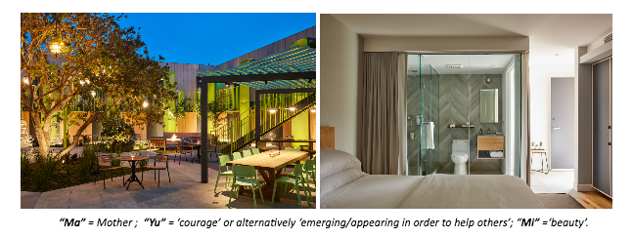
To view/download Mayumi Images by Roger Davies - Click HERE
Upscale communal hospitality space in Culver City, California, enhances onsite environment with a mobile access solution
Dallas, TX (May 4, 2018) – As travelers become more favorable towards implementing technological advances in their trips and experiences, the same desire for streamlined accessibility and convenience has emerged for their hotel check-in and home-living as well. That’s why Mayumi, a new 35-unit boutique hotel nestled in Culver City, California, has partnered with OpenKey, the industry standard for universal mobile key technology in hotels. Through this partnership, the Mayumi Hotel now offers an experience-focused technology platform with a mobile access solution that grants guests keyless access to their short- and long-term living spaces.
“Our demographic is all about openness, sharing, collaboration, and disrupting the more traditional living experience. We’re excited to see how this product takes shape with existing and new visitors to residents in the area, and we couldn’t think of a better way to hand them the keys to our creative communal-living space than by putting access to the property residences right on their smartphones,” said Robert Herscu of Mayumi.
Mobile technology offering entry access without a key or a key card is a recent focus of technological advancement in the hotel industry. OpenKey is pushing past the borders of the hotel industry and now establishing a name for the technology in the creative living space realm.
OpenKey has made much of that opportunity. Since launching in 2014, the Dallas-based company has grown from three to 30 employees globally and services hotels in eleven countries across four continents. The partnership with The Mayumi, a new boutique hotel under the umbrella of HQ Development, a Los Angeles-based developer of upscale creative office space, is the first step for OpenKey beyond hotels and into creative stay and living spaces.
Along with keyless access to their residences, short- and long-term occupants of the Mayumi can employ the OpenKey app to book amenities, notify the property of early or late arrival, receive property announcements and access Wi-Fi codes. Another plus for the civic-minded, environmentally conscious guests typically drawn to shared live and work spaces: OpenKey technology eliminates the need for disposable plastic keys.
Housed in Culver City, The Mayumi has been transformed into a creative stay and work space with design by architecture firm, Shubin Donaldson. The two-story property offers 35 units with private bathrooms, modern-luxury furnishings, storage, flat-screen smart televisions, smartphone controls and more. Residents share common spaces including a full kitchen with top of the line appliances and an expansive courtyard area equipped with work stations and dining areas including BBQ and fire pit areas as well as a shared complimentary laundry room. The Mayumi provides an affordable stay alternative for guests as nightly rates starting at with special arrangements for month-to-month stays.
“We are excited to go beyond our usual base in the hotel industry and introduce our experience-focus technology platform to the Mayumi,” said TJ Person, CEO at OpenKey. “As demand for creative hospitality space grows, guests will desire more and more technological innovation within their living arrangements. It’s exciting to be able to establish a foothold within this new segment of home-living in its early stages of development.”
About OpenKey
Founded in 2014, OpenKey is reinventing the hospitality experience through its mobile access solution. The OpenKey app is the industry standard for universal mobile key technology and works with the majority of digital hotel locks. Hotels and their guests benefit from OpenKey’s platform providing efficiency, convenience and cost savings. OpenKey is a privately held company located in Plano, Texas. The company has been funded by several of the largest hotel ownership and management companies in the world. The app is available for both iOS and Android devices. For more information, please visit www.openkey.co.
Media Contact for OpenKey:
Sophia Hargrove
OpenKey
shargrove@openkey.co / 469-661-0841
Media Contact for Mayumi:
Julia Axelrod
Evolutionary Media Group
Julia@emgpr.com / 323-658-8700

