Press Contact:  Nadja Weindl  Mail: nadja.weindl@dailypoint.net  Phone: +49 89 189 35 69 - 12 | Toedt, Dr. Selk & Coll. GmbH  Augustenstr. 79  80333 Munich, Germany  Phone: +49 89 189 35 69 - 0  Fax: +49 89 189 35 69 - 19

PRESS-release

Deutsche Hospitality relies on dailypointTM for "H Rewards

Munich, November 2020 – Deutsche Hospitality presented its new loyalty and rewards program
"H Rewards" in summer 2020. With the bonus program, Deutsche Hospitality opened up a significantly expanded benefits package for all guests of its five brands. Behind one of the most modern and efficient hotel bonus programs is dailypoint™.
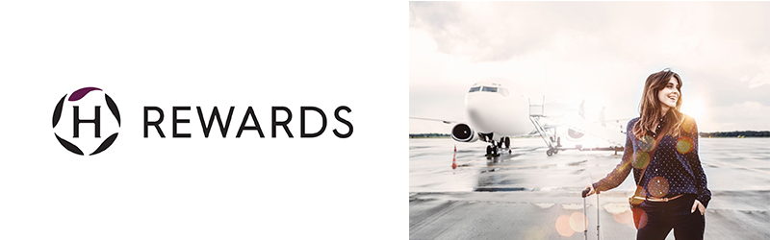
The new loyalty and rewards program of Deutsche Hospitality has been online since July 2020.
"H Rewards" includes all five hotel brands of Steigenberger Hotels AG/Deutsche Hospitality - including Steigenberger Hotels & Resorts, MAXX by Steigenberger, Jaz in the City, IntercityHotel and Zleep Hotels.

With this step, the hotel company is bringing itself up to date in terms of technology and now offers one system across all hotel brands. Necessary for the implementation was the technical know-how of dailypoint™ to bundle several customer loyalty programs in one system, and also to correctly implement the high standard of GDPR requirements. Partner systems include Miles&More, Payback and the customer loyalty program of Deutsche Bahn.

dailypoint™ has been the strategic partner for central data management and company-wide customer relationship management (CRM) since 2018. "Deutsche Hospitality has set itself the goal of playing a pioneering role in the digitalization of the industry. We are proud to be a central pillar in this," says Dr. Michael Toedt, founder and CEO of dailypoint™. The platform approach of dailypoint™, which enables the integration of additional systems quickly and easily, was decisive for the successful implementation. Besides Incert, one of the best voucher systems on the market, SynXis from Sabre is also part of the solution. The project was implemented by Workmatrix, one of the leading web agencies and specialized in the implementation of complex hotel websites. Stefan Elsner, managing director of Workmatrix emphasizes how well the cooperation of the partners in this project went. "The perfect connection of the different systems is nowadays the key to success", explains Stefan Elsner.

"For a company-wide and global CRM strategy, as well as a cross-brand and individualized approach to our guests and members, a central, cross-system guest profile plays the decisive role. dailypoint™ supports us in a wide range of processes within the new bonus program, from the registration process to the administration of the points account, the redemption of points, the sending of booking confirmations and, last but not least, the bundling of the points in a central guest profile," explains Christian Saliger, Director CRM & Loyalty at Deutsche Hospitality.

"The holistic approach at Deutsche Hospitality is unique. Hardly any other hotel company has discovered digitalization for itself and knows how to use it as well as this company", adds dailypoint™-CEO Dr. Michael Toedt.

About dailypoint™
dailypoint™ is the leading Data Management and CRM platform for sophisticated individual hotels and hotel groups. dailypoint™ collects data from all relevant sources such as PMS, POS, website, newsletter or WiFi and automatically creates a central and consolidated guest profile. In 350 steps, the data is processed and enriched by means of artificial intelligence (AI) to create a guest profile never seen before.

The cloud-based SAAS solution consists of 15 modules and is complemented by the dailypoint™ Marketplace with more than 140 solution partners. dailypoint™ not only offers measurable marketing, but also covers the entire customer journey and thus supports all departments within a hotel. The integrated Privacy Dashboard is also the central element for the technical implementation of the GDPR.

dailypoint™ is headquartered in Munich, Germany and is sold and supported worldwide directly or through its distribution partners D-EDGE and XNProtel.

Further information: www.dailypoint.com

About Deutsche Hospitality
Deutsche Hospitality is the umbrella brand for the companies of the Steigenberger Hotels AG. It sees itself as an international, dynamic hotel operator and is characterized by the values of passion, perfection, caring, tradition and vision. The company can look back on almost 90 years of history, which began in 1930 with the opening of the founding hotel – the Steigenberger Europäischer Hof in Baden-Baden. Deutsche Hospitality represents an outstanding portfolio: comprising over 150 hotels on three continents, of which more than 30 hotels are under development. Five hotel brands are managed under its umbrella: Steigenberger Hotels & Resorts (Luxury and Upper Upscale), MAXX by Steigenberger (Upscale), Jaz in the City (Lifestyle), IntercityHotel (Upper Midscale) and Zleep Hotels (Economy).

Further information: www.deutschehospitality.com & www.global.hrewards.com.

About workmatrix
Workmatrix GmbH, founded in 2001, is one of the leading agencies for hotel technology and hotel online marketing. Among the customers of Workmatrix GmbH are 25hours Hotel Company, citizenM, Novum Hospitality and Steigenberger Hotels AG.

Further information: www.workmatrix.de

word count: text only 2.846 words incl. blanks

Source: Steigenberger Hotels AG

